1. Name, describe, & give the biological significance of each descriptor.

|  |  |  |
| --- | --- | --- |
| Descriptor | Property/characteristic | Biological Significance |
| Water bonds to water |  |  |
| Ice floats |  |  |
| Water takes a long time to boil |  |  |
| Water bonds to glass |  |  |
| Water will dissolve many substances |  |  |
| Water has a partial positive and partial negative pole (end) |  |  |

1. Macromolecules are organic compounds/polymers that contain the element ______________.
2. All macromolecules are made up of the elements __________________________, _____________________________, and _______________________________.
3. Macromolecules are held together by __________________ bonds because they share electrons between them.
4. Name 2 functions of carbohydrates ________________________________________________________ __________________________________________________.
5. Fats are important in the construction of cell membranes and store ________________.
6. 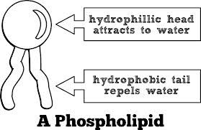This structure is a _______________________. Label the following parts of the molecule below:

______________________

______________________

1. In the above drawing which part is hydrophobic and which is hydrophilic?

Hydrophobic ______________________

Hydrophilic _______________________

1. What is a phospholipid bilayer? Do not answer what makes up the cell membrane. Describe its properties. ____________________________________________________________________________________________________________________________________________________________
2. Name 2 reasons why proteins are important (name 2 functions)? ____________________________________________________________________________________________________________________________________________________________
3. Proteins are molecules that are formed from subunits called _______________________.
4. What type of bond holds together amino acids? ____________________________
5. A long linear sequence of ***many*** amino acids is referred to as a ________________________.
6. Nucleic acids are composed of the subunit ________________________.
7. DNA & RNA are responsible for containing ________________________ information.
8. ATP is the universal “__________________ _______________________” for cells because it’s made in cells then used for many types of chemical reactions throughout the body.

|  |  |
| --- | --- |
| 1. ____nucleic acid 2. ____nucleotide 3. ____DNA 4. ____RNA 5. ____ATP 6. ____phospholipid 7. ____amino acid 8. ____Sugar | a. temporarily stores energy  b. involved in the production of proteins  c. subunit of proteins  d. one of the major classes of organic compounds  e. contains the genetic code  f. subunit of carbohydrates  g. subunit of DNA and RNA  h. found in cell membranes |

1. 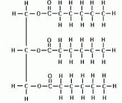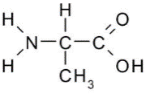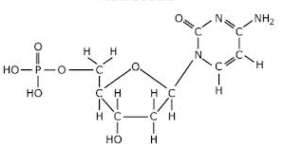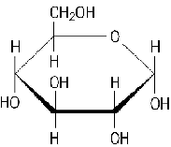Label the subunit, the class it participates in, and all functions you can think of.